**Sun County Panthers U13 2025-2026**

**Head Coach: Myles Doan**

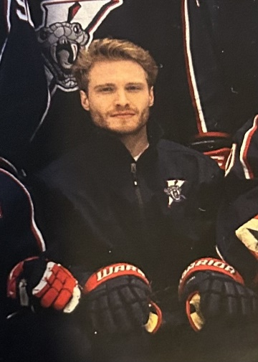

*Age: 32*

*Hometown: Windsor, Ontario*

*Coaching Philosophy and Values:*

*Utilizing both his experience as a player in the OHL and OUA and his Master’s degree in sport psychology, Myles offers a unique perspective on developing players both on and off the ice. He and his staff put a premium on leadership, communication, and personal growth which fosters healthy team environments and develops interpersonal skills that transcend a sport setting.*

*On-ice, Myles and his staff put a great focus on systematic and positional play, while still focusing on skill development. This is accomplished through detailed walk-throughs, video sessions, small area drills, and game-like scenarios. In terms of skill development, the staff possesses great knowledge on the fundamentals of skating, passing, shooting, and stick handling and how to apply it to game situations. With 10 years of experience as a skills and skating coach, Myles can identify players’ needs and how to improve them.*

*Coaching Career:*

*2024 - 2025: Biosteel Sports Academy 16U AAA*

*2023 – 2024: LaSalle Vipers Assistant Coach - GOJHL*

*HP1 Trained*

*Skating/Skill instructor (2015-Present)*

*Mental Performance Coach (M.H.K.)*

*Playing Career:*

***OHL****:*

*Owen Sound Attack (2008-2010)*

*Niagara IceDogs (2010-2012)*

***OUA****:*

*University of Windsor (2013-2014)*

*Education:*

*University of Windsor - Bachelor of Human Kinetics - B.H.K. (2017)*

*University of Windsor - Master’s of Human Kinetics - Sport and Exercise Psychology - M.H.K. (2023)*

*Assistant Coach* ***Chris Scott***

*Playing Career:*

*GOJHL: Leamington Flyers (2010-2015)*

*OUA: University of Windsor (2015-2018)*

*Sweden Div. 2:*

*Olofstroms IK (2018-2019)*

*Stenungsund HF (2018-2019)*

*See you at the SCP tryouts!*