**Sun County Panthers U14 2025-2026**

**Head Coach: Laine Parent**

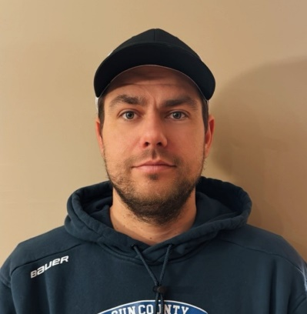

*Age:* 32

*Hometown:* Belle River, Ontario

**Coaching Achievements**

2022 Schmalz Cup Champion (PJHL Ontario Jr.C)

2018 OMHA U18 AA Champion

**Values:**

This staff advocates for a development-first approach, emphasizing exposure to various game situations that promote adaptability, decision-making, and confidence on the ice. The coaching staff utilizes small-area games and high-intensity drills to foster hockey IQ, strong body positioning, and situational awareness in each player while leveraging systems in all 3 zones.

"Games are an opportunity for growth, and practices are where we build the skills to succeed. Our goal is to create competitive athletes who are prepared for any situation the game throws at them, now and in the future."

**Coaching Career:**

2024 - 2025: Sun County Panthers Head Coach (U13)

2023 – 2024: Belle River Jr. Canadiens A Head Coach (U16)

2018 – 2023: Lakeshore Canadiens Assistant / Video Coach (Jr. C)

2015 – 2018: Belle River Jr. Canadiens AA Assistant Coach (U15 – U18)

**Playing Career:**

Goaltender

*Jr. C:* Wheatley Sharks (2009-2010), Napanee Raiders (2010-2011), Kingsville Comets (2012-2013)

*Jr. A:* Smith Falls Bears (2011-2012), Soo. Thunderbirds (2011-2012), Kingston Voyageurs (2010-2011)

**Assistant Coach: Kade Beuglet**

2024 – 2025: Sun County Panthers Assistant Coach (U13)

2021 – 2024: Belle River Jr. Canadiens Assistant Coach (U14 – U16)

Belle River Checking and Body Contact Clinic and League Instructor / Coach

2018 OMHA U18 AA Champion

**Assistant Coach / Trainer: Evan Taylor**

2024 – 2025: Sun County Panthers Assistant Coach / Trainer (U13)

2022 – 2024: Belle River Jr. Canadiens Assistant Coach / Trainer (U15 – U16)

2018 OMHA U18 AA Champion

*See you at the SCP tryouts!*